ASSIGNMENT-1

1.EXAMPLE OF PROPAGANDA COMMUNICATION

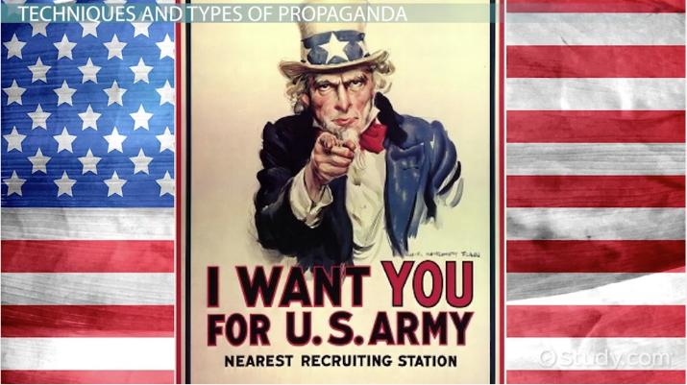

2.EXAMPLE OFA COMMUNICATION USING THE TWO STEPS FLOW STRATEGY

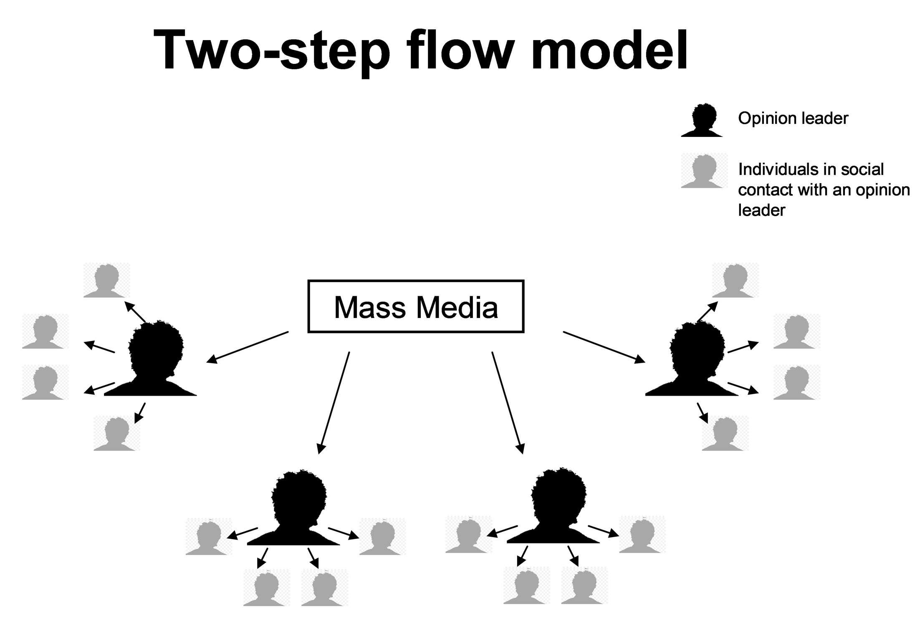

3. EXAMPLE OF COMMUNICATION TARGETING YOUNG MEN.



4.EXAMPLE OF COMMUNCATION TARGATING YOUNG WOMEN



5.EXAMPLE OF PUBLIC SERVICE COMMUNICATION

